EXPERIMENT-6

Lab 6: Use of different SQL clauses and join

Objective: To understand the use of group by and having clause and execute the SQL commands using JOIN

Understanding JOINs in MySQL
- A join enables you to retrieve records from two (or more) logically related tables in a single result set.
- JOIN clauses are used to return the rows of two or more queries using two or more tables that share a meaningful relationship based on a common set of values.
- These values are usually the same column name and datatype that appear in both the participating tables being joined. These columns, or possibly a single column from each table, are called the join key or common key.
- Mostly but not all of the time, the join key is the primary key of one table and a foreign key in another table. The join can be performed as long as the data in the columns are matching.
- It can be difficult when the join involves more than two tables. It is a good practice to think of the query as a series of two table joins when the involvement of three or more tables in joins.

MySQL JOIN

MySQL supports the following JOIN syntaxes for the table_references (A table reference is also known as a join expression.) part of SELECT statements and multiple-table UPDATE and DELETE statements :

Types of MySQL Joins

INNER JOIN 2. LEFT JOIN 3. RIGHT JOIN 4. STRAIGHT JOIN 5. CROSS JOIN 6. NATURAL JOIN 1. INNER JOIN

In MySQL the INNER JOIN selects all rows from both participating tables to appear in the result if and only if both tables meet the conditions specified in the ON clause. JOIN, CROSS JOIN, and INNER JOIN are syntactic equivalents. In standard SQL, they are not equivalent. INNER JOIN is used with an ON clause, CROSS JOIN is used otherwise.

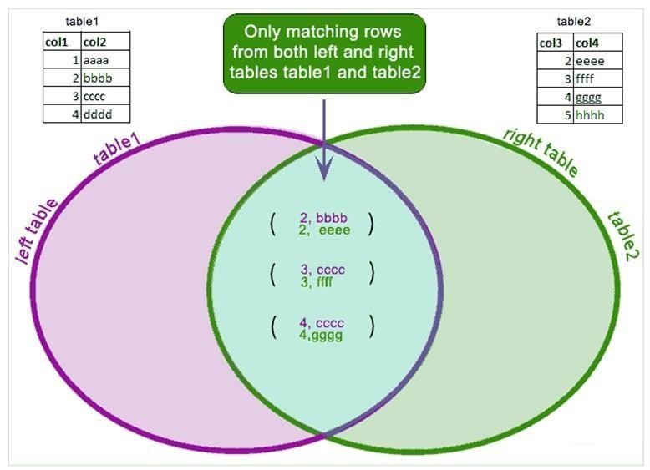
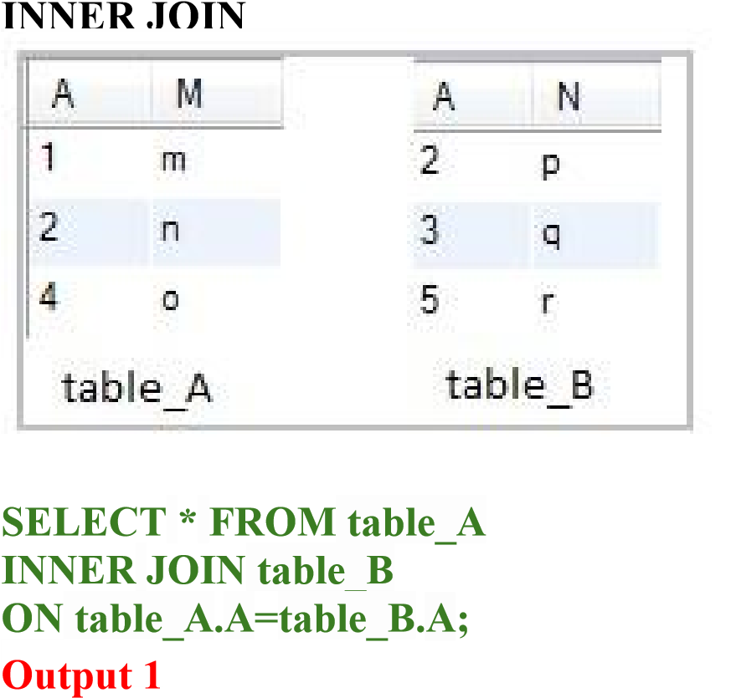

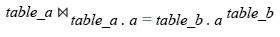

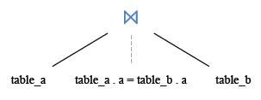

book_mast
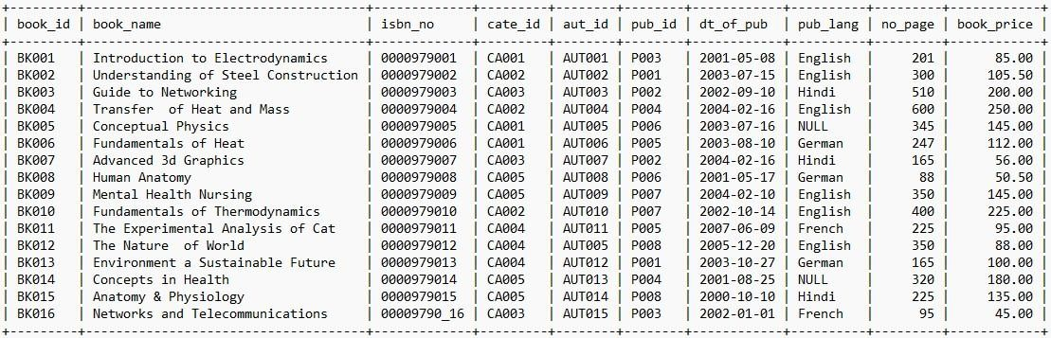

Category
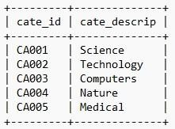




, cate_descrip
SELECT  FROM b  INNER  N book  WHERE                  Output 2 |   book_mast | book_id  . ,  r y            id = catego pub_lan  ry  g | book_mast   .  . cate_id      = "English"; | book_nam e  
ook_mast
JOIN catego







_mast. cate_ book_mast .

O



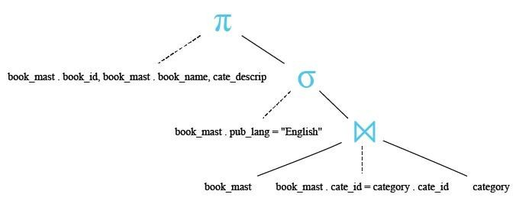

INNER JOIN with alias

SELECT bk.book_id,bk.book_name,bk.pub_id,ca.cate_descrip,bk.pub_lang FROM book_mast AS bk
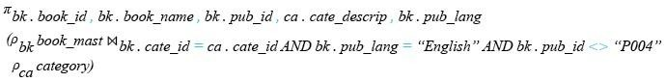
INNER JOIN category AS ca ON bk.cate_id=
ca
.
cate_id
AND
bk
.pub_lang="English" AND bk.pub_id<>'P004';

Output 3

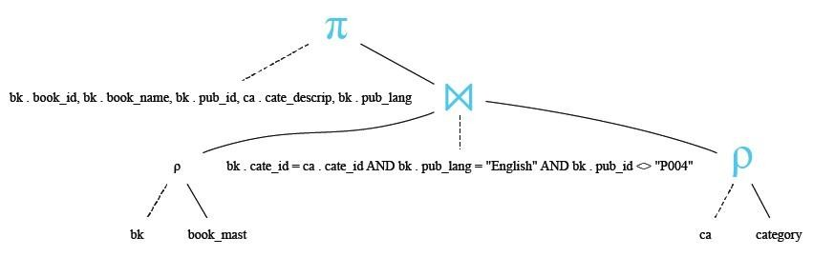

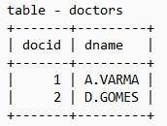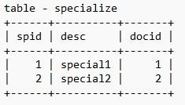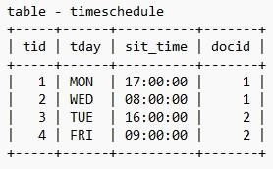
INNER JOIN using three tables

SELECT a.docid,a.dname,

b.desc,c.tday,c.sit_time

FROM doctors a

INNER JOIN specialize b

ON

a
.docid=b.docid

INNER JOIN timeschedule c

ON

a
.docid=c.docid

WHERE a.docid=1
AND

c
.
tday
=
'WED';

Output 4

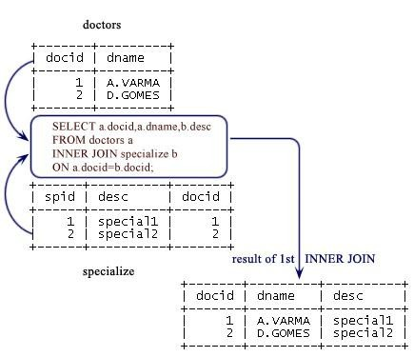
Explanation :

Step-1
SELECT a.docid,a.dname,b.desc
FROM doctors a
INNER JOIN specialize b
ON a.docid=b.docid;

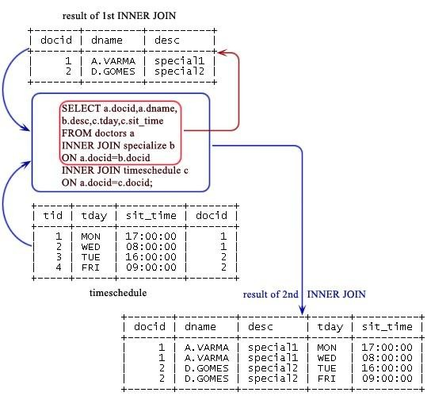
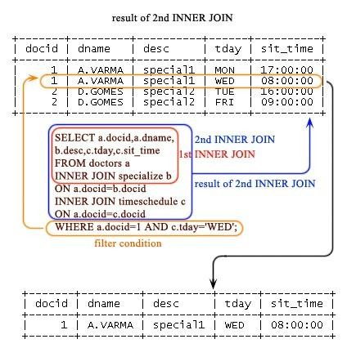
Step-2

SELECT a.docid,a.dname, b.desc,c.tday,c.sit_time FROM doctors a
INNER JOIN specialize b
ON a.docid=b.docid
INNER JOIN timeschedule c
ON a.docid=c.docid;

Step-3
SELECT a.docid,a.dname, b.desc,c.tday,c.sit_time FROM doctors a
INNER JOIN specialize b
ON a.docid=b.docid
INNER JOIN timeschedule c
ON a.docid=c.docid
WHERE a.docid=1 AND c.tday='WED';

LEFT JOIN

The MySQL LEFT JOIN joins two tables and fetches rows based on a condition, which is matching in both the tables and the unmatched rows will also be available from the table written before the JOIN clause.

SELECT * FROM table_A
LEFT JOIN table_B
ta | ble_A
ON.A=table_B.A;

Output 5

SELECT bk1.book_name,bk1.isbn_no,bk1.book_price,bk1.pub_lang
FROM book_mast bk1
LEFT JOIN book_mast bk2 ON bk1.book_price<bk2.book_price
WHERE bk2.pub_lang='German';
Output 6

RIGHT JOIN

The RIGHT JOIN is such a join which specifies that all records be fetched from the table on the right side of the join statement, even if the table on the left has no matching record. In this case, the columns from the left table return NULL values.

SELECT * FROM table_A
RIGHT JOIN table_B
ON table_A.A=table_B.A;

Output 7

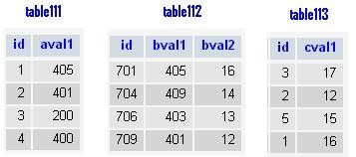
SELECT table112.id,table112.bval1,table112.bval2, table111.id,table111.aval1
FROM table112
RIGHT JOIN table111
ON table112.bval1=table111.aval1;

Output 8

SELECT table112.id,table112.bval1,table112.bval2, table111.id,table111.aval1
FROM table112
RIGHT OUTER JOIN table111
ON table112.bval1=table111.aval1;

Output 9
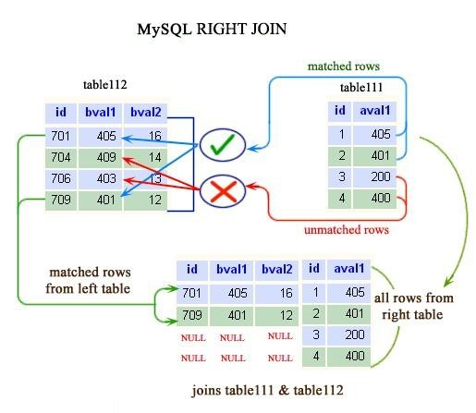
SELECT table113.id,table113.cval1, table111.id,table111.aval1
FROM table113
RIGHT OUTER JOIN table111
USING(id);
Output 10

STRAIGHT JOIN

A STRAIGHT_JOIN is such a join which scans and combines matching rows ( if specified any condition) which are stored in associated tables otherwise it behaves like an INNER JOIN or JOIN of without any condition.

SELECT * FROM table_A
STRAIGHT JOIN table_B;

Output 11

SELECT table112.id,table112.bval1,table112.bval2, table111.id,table111.aval1
FROM table112
STRAIGHT_JOIN table111;

Output 12

SELECT table113.id,table113.cval1, table111.id,table111.aval1
FROM table113
STRAIGHT_JOIN table111
ON table113.id=table111.id;
Output 13

CROSS JOIN

A CROSS JOIN is such a join which specifies the complete cross product of two tables. For each record in the first table, all the records in the second table are joined, creating a potentially huge result set. This command has the same effect as leaving off the join condition, and its result set is also known as a Cartesian product.

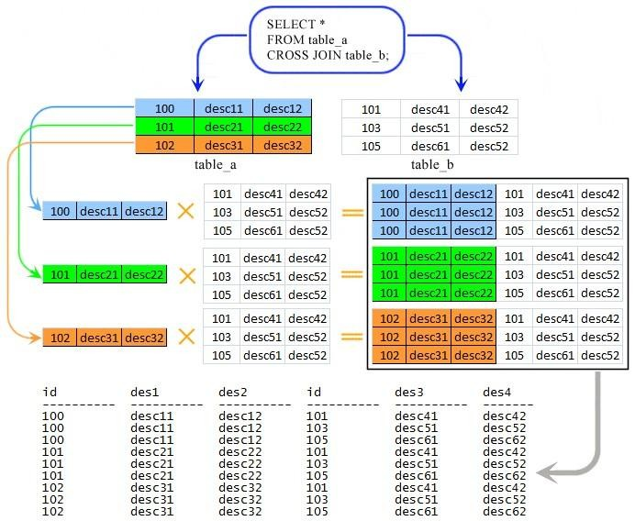
SELECT * FROM table_A CROSS JOIN table_B; Output 14

SELECT table112.id,table112.bval1,table112.bval2, table111.id,table111.aval1 FROM table112
CROSS JOIN table111;

Output 15

SELECT *
FROM table111
LEFT JOIN(table112 CROSS JOIN table113)
ON table111.id=table113.id;

Output 16

SELECT table111.*,table113.*
FROM table111
CROSS JOIN table113
WHERE table111.id=table113.id; Output
17

NATURAL JOIN

A NATURAL JOIN is such a join that performs the same task as an INNER or LEFT JOIN, in which the ON or USING clause refers to all columns that the tables to be joined have in common.

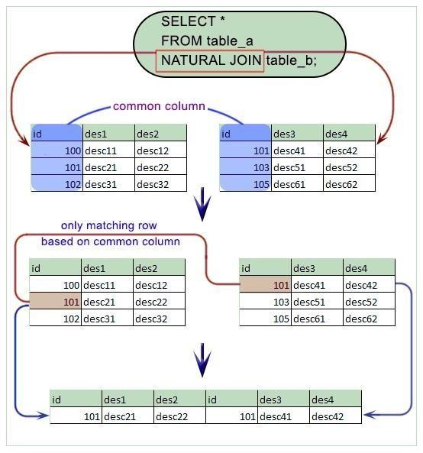
SELECT * FROM table_A NATURAL JOIN table_B; Output 18
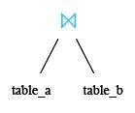

NATURAL JOIN

SELECT id,aval1,cval1
FROM table111
NATURAL JOIN table113;
Output 19

INNER JOIN using ON clause

SELECT table1111.id,table111.aval1,table113.cval1
FROM table111
INNER JOIN table113
ON table111.id=table113.id;
Output 20

NATURAL JOIN with WHERE clause

SELECT id,aval1,cval1
FROM table111
NATURAL JOIN table113
WHERE table111.aval1>200;
Output 21

NATURAL JOIN using three tables

SELECT id,aval1,cval1
FROM table111 NATURAL
JOIN table113 natural join table114 WHERE table111.aval1>200; Output

22

